Московский государственный технический университет им. Н.Э. Баумана

Факультет «Информатика и системы управления»

Кафедра ИУ5 «Системы обработки информации и управления»

Курс   
«Технологии машинного обучения»  
 Отчет по лабораторной работе №5

«Разведочный анализ данных. Исследование и визуализация данных.»

|  |  |
| --- | --- |
| Выполнил: | Проверил: |
| студент группы ИУ5-63Б | преподаватель каф. ИУ5 |
| Тарновский Д.Р. | Гапанюк Ю.Е. |

Москва, 2022 г.

In [3]:

*#Датасет содержит данные о кредитах на покупку электроники, которые были*

**import** pandas **as** pd

**import** numpy **as** np

**from** matplotlib **import** pyplot **as** plt

**import** seaborn **as** sns

**from** sklearn.model_selection **import** train_test_split, GridSearchCV, Rand

**from** sklearn.neighbors **import** KNeighborsClassifier

**from** sklearn.preprocessing **import** MinMaxScaler, StandardScaler

**from** sklearn.linear_model **import** LogisticRegression, LogisticRegressionC **from** sklearn.ensemble **import** RandomForestClassifier, GradientBoostingCla **from** sklearn.metrics **import** accuracy_score, precision_score, recall_scor **from** sklearn.neural_network **import** MLPClassifier

**from** warnings **import** simplefilter

simplefilter('ignore')

In [4]:

*# записываем CSV-файл в объект DataFrame*

data **=** pd**.**read_csv('credit_train_preprocess.csv', encoding**=**'cp1251', sep

In [5]:

*# смотрим на первые пять строк*

data**.**head() data**.**info()

<class 'pandas.core.frame.DataFrame'> RangeIndex: 170746 entries, 0 to 170745 Data columns (total 39 columns):

# Column Non-Null Count Dtype

|  |  |  |  |
| --- | --- | --- | --- |
| 0 age | 170746 | non-null | float64 |
| 1 credit_sum | 170746 | non-null | float64 |
| 2 credit_month | 170746 | non-null | int64 |
| 3 tariff_id | 170746 | non-null | float64 |
| 4 score_shk | 170746 | non-null | float64 |
| 5 monthly_income | 170746 | non-null | float64 |
| 6 credit_count | 170746 | non-null | float64 |
| 7 overdue_credit_count | 170746 | non-null | float64 |
| 8 open_account_flg | 170746 | non-null | int64 |
| 9 gender_F | 170746 | non-null | int64 |
| 10 gender_M | 170746 | non-null | int64 |
| 11 job_position_ATP | 170746 | non-null | int64 |
| 12 job_position_BIS | 170746 | non-null | int64 |
| 13 job_position_BIU | 170746 | non-null | int64 |
| 14 job_position_DIR | 170746 | non-null | int64 |
| 15 job_position_HSK | 170746 | non-null | int64 |
| 16 job_position_INP | 170746 | non-null | int64 |
| 17 job_position_INV | 170746 | non-null | int64 |
| 18 job_position_NOR | 170746 | non-null | int64 |
| 19 job_position_ONB | 170746 | non-null | int64 |
| 20 job_position_PNA | 170746 | non-null | int64 |
| 21 job_position_PNI | 170746 | non-null | int64 |
| 22 job_position_PNS | 170746 | non-null | int64 |
| 23 job_position_PNV | 170746 | non-null | int64 |

|  |  |  |  |
| --- | --- | --- | --- |
| 24 job_position_SPC | 170746 | non-null | int64 |
| 25 job_position_UMN | 170746 | non-null | int64 |
| 26 job_position_WOI | 170746 | non-null | int64 |
| 27 job_position_WRK | 170746 | non-null | int64 |
| 28 job_position_WRP | 170746 | non-null | int64 |
| 29 education_ACD | 170746 | non-null | int64 |
| 30 education_GRD | 170746 | non-null | int64 |
| 31 education_PGR | 170746 | non-null | int64 |
| 32 education_SCH | 170746 | non-null | int64 |
| 33 education_UGR | 170746 | non-null | int64 |
| 34 marital_status_CIV | 170746 | non-null | int64 |
| 35 marital_status_DIV | 170746 | non-null | int64 |
| 36 marital_status_MAR | 170746 | non-null | int64 |
| 37 marital_status_UNM | 170746 | non-null | int64 |
| 38 marital_status_WID | 170746 | non-null | int64 |

In [7]:

corr **=** data**.**corr()**.**round(2)

f, ax **=** plt**.**subplots(figsize**=**(20, 20))

cmap **=** sns**.**diverging_palette(120, 50, as_cmap**=True**) sns**.**heatmap(data**=**corr, cmap**=**cmap, annot**=True**, vmax**=**1.0, square**=True**, lin plt**.**show()

dtypes: float64(7), int64(32) memory usage: 50.8 MB

# Корреляционный анализ

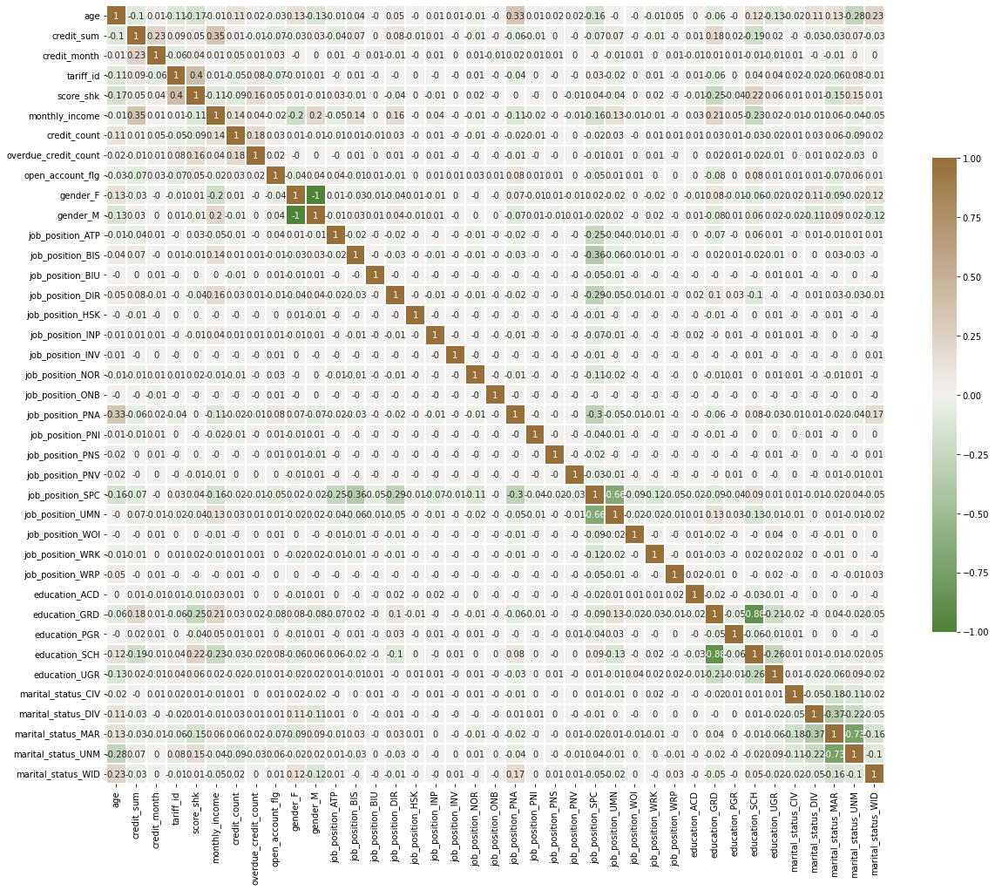

In [8]:

print('Признаки, имеющие максимальную по модулю корреляцию с целевым при best_params **=** data**.**corr()['open_account_flg']**.**map(abs)**.**sort_values(ascen

best_params **=** best_params[best_params**.**values **>** 0.02] best_params

Out[8]:

In [9]:

Признаки, имеющие максимальную по модулю корреляцию с целевым признаком education_GRD 0.082371

education_SCH 0.078337

job_position_PNA 0.076889

credit_sum 0.072039

tariff_id 0.067346

marital_status_MAR 0.067112

marital_status_UNM 0.061312

job_position_SPC 0.049143

score_shk 0.048686

gender_F 0.044265

gender_M 0.044265

job_position_ATP 0.038288

credit_count 0.032374

age 0.031062

job_position_NOR 0.027320

credit_month 0.025809

monthly_income 0.023697

Name: open_account_flg, dtype: float64

corr **=** data[best_params**.**index]**.**corr()**.**round(2) f, ax **=** plt**.**subplots(figsize**=**(20, 20))

cmap **=** sns**.**diverging_palette(120, 50, as_cmap**=True**)

sns**.**heatmap(data**=**corr, cmap**=**cmap, annot**=True**, vmax**=**1.0, square**=True**, lin plt**.**show()

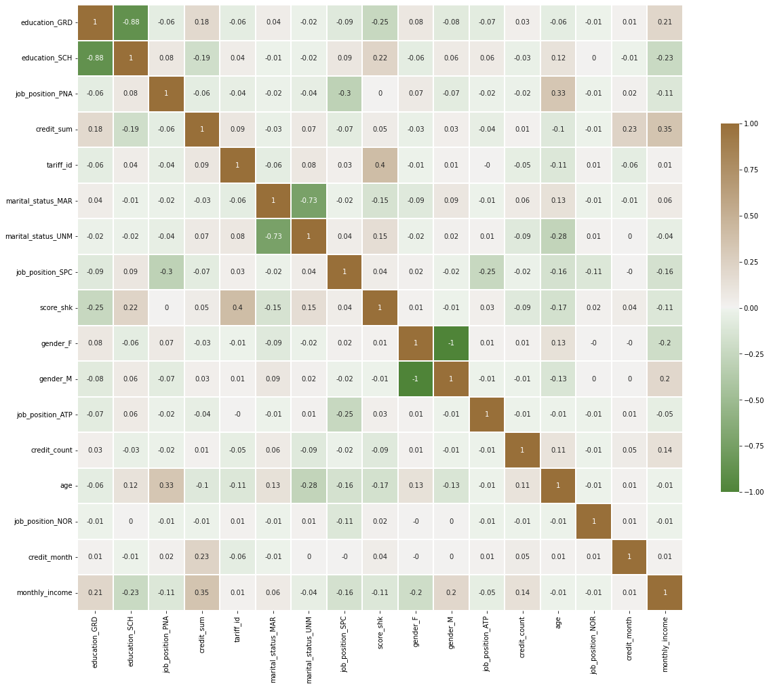

In [10]:

plt**.**figure(figsize**=**(6, 8)) sns**.**heatmap(pd**.**DataFrame(data[np**.**append(best_params**.**index**.**values, 'open_ plt**.**show()

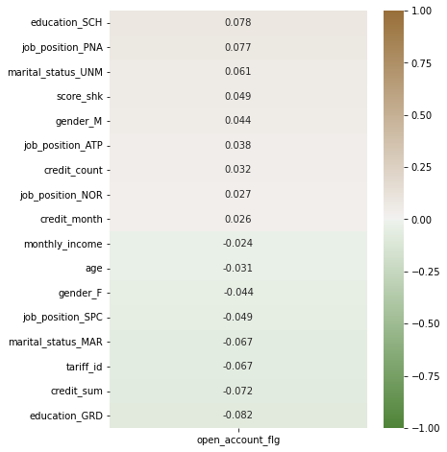

In [11]:

data_best **=** data[best_params**.**index] data_best**.**head()

# Разделение выборки на обучающую и тестовую

|  |  |  |  |  |  |  |
| --- | --- | --- | --- | --- | --- | --- |
| Out[11]: | **education_GRD** | **education_SCH** | **job_position_PNA** | **credit_sum** | **tariff_id** | **marital_status_M** |
|  | **0** 1 | 0 | 0 | 59998.00 | 1.6 |  |
|  | **1** 0 | 1 | 0 | 10889.00 | 1.1 |  |
|  | **2** 0 | 1 | 0 | 10728.00 | 1.1 |  |
|  | **3** 0 | 1 | 0 | 12009.09 | 1.1 |  |
|  | **4** 0 | 1 | 0 | 21229.00 | 1.1 |  |

In [12]:

y **=** data['open_account_flg']

*#X = data.drop('open_account_flg', axis=1)*

X **=** data_best

x_train, x_test, y_train, y_test **=** train_test_split(X, y, test_size**=**0.75 x_train, x_test, y_train, y_test **=** train_test_split(x_train, y_train, te

# Масштабирование данных

In [13]:

scaler **=** MinMaxScaler()**.**fit(x_train)

x_train **=** pd**.**DataFrame(scaler**.**transform(x_train), columns**=**x_train**.**column x_test **=** pd**.**DataFrame(scaler**.**transform(x_test), columns**=**x_train**.**columns) x_train**.**describe()

|  |  |  |  |  |  |  |
| --- | --- | --- | --- | --- | --- | --- |
| Out[13]: | **education_GRD** | **education_SCH** | **job_position_PNA** | **credit_sum** | **tariff_id** | **mari** |
|  | **count** 29880.000000 | 29880.000000 | 29880.000000 | 29880.000000 | 29880.000000 |  |
|  | **mean** 0.425000 | 0.514759 | 0.023561 | 0.117340 | 0.345539 |  |
|  | **std** 0.494351 | 0.499790 | 0.151679 | 0.082275 | 0.252486 |  |
|  | **min** 0.000000 | 0.000000 | 0.000000 | 0.000000 | 0.000000 |  |
|  | **25%** 0.000000 | 0.000000 | 0.000000 | 0.060249 | 0.106383 |  |
|  | **50%** 0.000000 | 1.000000 | 0.000000 | 0.092536 | 0.340426 |  |
|  | **75%** 1.000000 | 1.000000 | 0.000000 | 0.148270 | 0.638298 |  |
|  | **max** 1.000000 | 1.000000 | 1.000000 | 1.000000 | 1.000000 |  |

In [82]:

**from** sklearn.metrics **import** mean_absolute_error

**from** sklearn.metrics **import** median_absolute_error, r2_score

**def** print_metrics(y_test, y_pred):

print(f"Precision: {precision_score(y_test, y_pred)}") print(f"F1-measure: {f1_score(y_test, y_pred)}")

print('mean_absolute_error: {}'**.**format(round(mean_absolute_error(y_t print('median_absolute_error: {}'**.**format(round(median_absolute_error print('r2_score: {}'**.**format(round(r2_score(y_test, y_pred), 2)))

# Модель №1: Случайный лес

In [15]:

print_metrics(y_test, RandomForestClassifier(random_state**=**17)**.**fit(x_trai

In [90]:

Precision: 0.4737991266375546

F1-measure: 0.15617128463476068

# Подбор гиперпараметров

{'max_features': 'auto', 'min_samples_leaf': 5, 'n_estimators': 1000}

rf **=** RandomForestClassifier(random_state**=**17) params **=** {'n_estimators': [100, 1000],

'max_features': ['auto', 'sqrt'], 'min_samples_leaf': [1, 3, 5 grid_cv **=** GridSearchCV(estimator**=**rf, cv**=**5, param_grid**=**params, n_jobs**=-**1, grid_cv**.**fit(x_train, y_train)

print(grid_cv**.**best_params_)

In [ ]:

best_rf **=** grid_cv**.**best_estimator_ best_rf**.**fit(x_train, y_train) y_pred_rf **=** best_rf**.**predict(x_test) print_metrics(y_test, y_pred_rf)

In [16]:

print_metrics(y_test, GradientBoostingClassifier(random_state**=**17)**.**fit(x_

# Модель №2: Градиентный бустинг

In [76]:

Accuracy: 0.8218803685772295

Precision: 0.5819672131147541

Recall: 0.06118052563550194

F1-measure: 0.11072124756335285

# Подбор гиперпараметров

{'min_samples_leaf': 5, 'n_estimators': 200}

gb **=** GradientBoostingClassifier(random_state**=**17)

params **=** {'n_estimators': [10, 50, 100, 200], 'min_samples_leaf': [1, 3, grid_cv **=** GridSearchCV(estimator**=**gb, cv**=**5, param_grid**=**params, n_jobs**=-**1, grid_cv**.**fit(x_train, y_train)

print(grid_cv**.**best_params_)

In [77]:

best_gb **=** grid_cv**.**best_estimator_ best_gb**.**fit(x_train, y_train) y_pred_gb **=** best_gb**.**predict(x_test) print_metrics(y_test, y_pred_gb)

In [24]:

dataset **=** Dataset(x_train, y_train, x_test)

Precision: 0.5709876543209876

F1-measure: 0.13988657844990549

# Модель №3: Стекинг

In [97]:

**from** sklearn.ensemble **import** RandomForestClassifier, StackingClassifier,

**from** sklearn.linear_model **import** LogisticRegression

**from** sklearn.linear_model **import** SGDClassifier **from** sklearn.neighbors **import** KNeighborsClassifier **from** sklearn.tree **import** DecisionTreeClassifier

layer_one_estimators **=** [

('rf_1', RandomForestClassifier(n_estimators**=**10, ('rf_3', GradientBoostingClassifier(n_estimators

]

layer_two_estimators **=** [

('dt_2', DecisionTreeClassifier()),

('rf_2', RandomForestClassifier(n_estimators**=**10, ('rf_4', GradientBoostingClassifier(n_estimators

]

layer_two **=** StackingClassifier(estimators**=**layer_two_estimators, final_es

*# Create Final model by*

clf **=** StackingClassifier(estimators**=**layer_one_estimators, final_estimato

*#layer_2 = StackingClassifier(estimators=profi_learners, final_estimator #layer_1 = StackingClassifier(estimators=base_learners, final_estimator=*

clf**.**fit(x_train, y_train)

Out[97]:

StackingClassifier(estimators=[('rf_1',

RandomForestClassifier(n_estimators=10,

random_state=42)),

00))],

2',

('rf_3',

GradientBoostingClassifier(n_estimators=2 final_estimator=StackingClassifier(estimators=[('dt_

Decisi

onTreeClassifier()), 2',

ForestClassifier(n_estimators=10,

('rf_ Random

In [98]:

random_state=42)), 4',

ntBoostingClassifier(n_estimators=20))],

Classifier(random_state=1488)))

print_metrics(y_test, clf**.**predict(x_test))

('rf_ Gradie

final_estimator=MLP

In [6]:

Precision: 0.6148148148148148

F1-measure: 0.12813585488228482

mean_absolute_error: 0.18

median_absolute_error: 0.0

r2_score: -0.19

# Сравнение моделей

Случайный лес

print("Случайный лес") print_metrics(y_test, y_pred_rf)

print("\nГрадиентный бустинг") print_metrics(y_test, y_pred_gb)

print("\nСтекинг") print_metrics(y_test, y_pred_stack)

**~\AppData\Local\Temp/ipykernel_12728/287930607.py** in <module>

1 print**("Случайный лес")**

**----> 2** print_metrics**(**y_test**,** y_pred_rf**)** 3

1. print**("\nГрадиентный бустинг")**
2. print_metrics**(**y_test**,** y_pred_gb**)**

**NameError**: name 'print_metrics' is not defined

Traceback (most recent call las

**--**

**NameError**

t)

In [ ]: